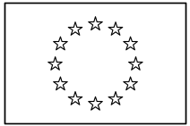 | EUROPEAN COMMISSION  DIRECTORATE-GENERAL  INFORMATICS  Information Systems Directorate

European Commission
UC0160 - eTrustEx Admin Console - Manage Party Agreements

Date: | 20/01/201707/10/2016
Version: | 21.000000
Authors: | Anamaria BATRINU (DIGIT-EXT)
Revised by: | Olivier DERVEAU (DIGIT-EXT)  Cristian CHIRIAC (DIGIT-EXT)
Approved by:
Public:
Reference Number:
TABLE OF CONTENTS
1. Use-Case Description 6
1.1. Primary Actor 6
1.2. Definitions, Acronyms and Abbreviations 7
1.3. References 7
1.4. Context Diagram 8
1.4.1. CIPA Administration Console 8
1.4.2. Manage Party Agreements module 9
2. Flow of events 9
2.1. Basic Creation Flow 9
2.1.1. User chooses the Create Party Agreement menu action 9
2.1.2. System displays the "Create Party Agreement" page 9
2.1.3. User enters information and chooses the Save option 9
2.1.4. System creates the Party Agreement 10
2.1.5. User acknowledges the successful message 10
2.1.6. System redisplays the saved Party Agreement in view mode 10
2.1.7. The basic creation flow ends. 10
2.2. Basic search flow 10
2.2.1. User selects the Search Party Agreement menu action 10
2.2.2. System displays the "Search Party Agreement" page 11
2.2.3. User enters the search criteria 11
2.2.4. The System searches the Party Agreements 11
2.2.5. System displays the Party Agreements found 11
2.2.6. User views the result list 11
2.2.7. The basic search flow ends. 11
2.3. Basic Visualization Flow 12
2.3.1. User has successfully saved a party agreement using the creation/modification flow or at step 2.2.6, User clicks a Party Agreement in the list 12
2.3.2. System opens the Party Agreement visualization page 12
2.3.3. User visualises the details of the Party Agreement: 12
2.3.4. Visualization flow ends. 12
2.4. Basic Modification Flow 12
2.4.1. At 2.3.3., The User chooses to edit a Party Agreement 12
2.4.2. System opens the Party Agreement page in edit mode 12
2.4.3. User makes the changes 12
2.4.4. The system saves the modified Party Agreement 12
2.4.5. User acknowledges the successful message 13
2.4.6. System redisplays the Party Agreement in view mode 13
2.4.7. The Modification flow ends. 13
2.5. Basic Deletion Flow 13
2.5.1. At 2.3.3., User chooses to delete the Party Agreement 13
2.5.2. System asks for deletion confirmation 14
2.5.3. User confirms the deletion 14
2.5.4. System deletes the Party Agreement 14
2.5.5. System notifies user of the success of the operation 14
2.5.6. User acknowledges the message 14
2.5.7. The Deletion Flow ends. 14
2.6. Subflows 14
2.6.1. S1: Search for an Authorizing / Delegated Party and select it 14
2.7. Alternative Flows 14
2.7.1. AC1: at step 2.1.3., User chooses Cancel option 14
2.7.2. AC2: at step 2.1.3, User chooses page Clear option 15
2.7.3. AC3: at step 2.1.3, user does not want authorization on all transactions 15
2.7.4. AS1: at step 2.2.4, no party agreement found for the specified criteria 15
2.7.5. AM1: at step 2.4.3, User chooses Cancel option 15
2.7.6. AM2: at step 2.4.3, User chooses Reset option 15
2.7.7. A1: at steps 2.1.3, or 2.4.3, User chooses to search for a Transaction 15
2.7.8. A2: at steps 2.1.3 or 2.4.3, User chooses to clear the corresponding Authorizing Party or Delegated Party 15
2.7.9. A3: at step 2.1.3 or 2.4.3, the user wants to remove a transaction from the authorized transactions list 16
2.8. Exceptional Flows 16
2.8.1. E1: at steps 2.1.1, 2.2.1, 2.4.1 or 2.5.1 user is not authorized for the operation 16
2.8.2. E2: at step 2.1.4 or 2.4.4, Business Rules are not verified 16
2.8.3. E3: at step 2.1.4 or 2.4.4, there is an error when saving the party agreement 16
2.8.4. E4: at step 2.5.4, there is an error when deleting the party agreement 16
2.8.5. E5: at any step, a technical error occurs 16
3. Special Requirements 17
3.1. Interface(s) with other Systems 17
3.2. Security Requirements 17
3.3. Other Special Requirement 17
4. Preconditions 17
5. Post conditions 17
6. Additional Information 17
6.1. Includes 17
6.2. Extends 17
7. Mock-up screens 17
7.1. Accessing Party Agreement Operations 17
7.2. "Create Party Agreement" page 18
7.3. "Search Party Agreement" page 19
7.4. "View Party Agreement" page 20
7.5. "Modify Party Agreement" page 21
7.6. "Delete Party Agreement" page 21

Document History

Version | Date | Comment | Modified Pages
0.001 | 26/05/2015 | First draft (JIRA CIPADMIN-200) | All
1.000 | 07/10/2016 | First version (JIRA ETRUSTEX-1666) | Where needed
1.001 | 26/10/2016 | ETRUSTEX-1392
1.002 | 24/11/2016 | ETRUSTEX-1392: added 2 new business rules and specified default selection in the party search popup as suggested during development.
1.003 | 16/12/2016 | ETRUSTEX-2086: added check of duplicates (BR16) | Section 2.1.4 System creates the Party Agreement
2.000 | 23/01/2017 | Removing menues from mock-up screens and changing the chain actions needed to trigger the main flows from the menu.

Use-Case Description
This use case depicts the sequence of actions that a user needs in order to create a Party Agreement, as well as the management actions that correspond to a created Party Agreement, such as Update, Delete, View and Search.
A party agreement is a contract based on which a party, called authorising or delegating party, authorises another party, called authorised or delegated party, to act in its behalf. This delegated party is also known under the name of third party.
The "Party Agreement Management" service is exposed on the CIPAdmin module of e-Trustex platform.
In the remainder of the document the CIPAdmin application will be referred to as the System.

Primary Actor
A human user can access the Manage Party Agreement feature via CIPAdmin interface. For detailed user access rights on each feature option, please see UC 0100 - eTrustEx Admin Console - Authenticate and Authorise User, section 6.3 User Access Rights.
In the remainder of the document, the user will be referred to as User or by his/her role, in those cases where role specific rules apply.

Definitions, Acronyms and Abbreviations
Acronym, Abbreviation or Definition | Explanation
CIPA | Common Infrastructure for Public Administrations
CIPADMIN | CIPA AdminConsole
UC(s) | Use Case(s)

References
Ref. | Title / description
[R1] | UC 0100 - eTrustEx Admin Console - Authenticate and Authorise User

Context Diagram

CIPA Administration Console
The diagram below depicts all the Services available on the CIPA Administration Console for e-TrustEx platform. Depending on the user role, only a subset of those services is exposed on the e-TrustEx Administration Console home page.
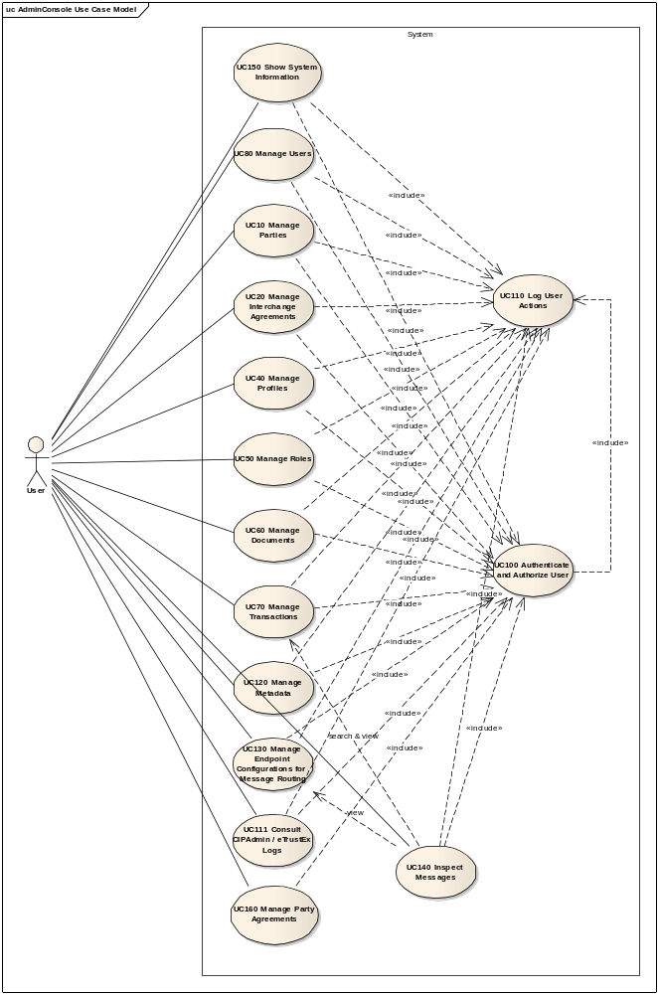

Manage Party Agreements module
The diagram below depicts how this use case interacts with other use cases implemented in the Administration Console.
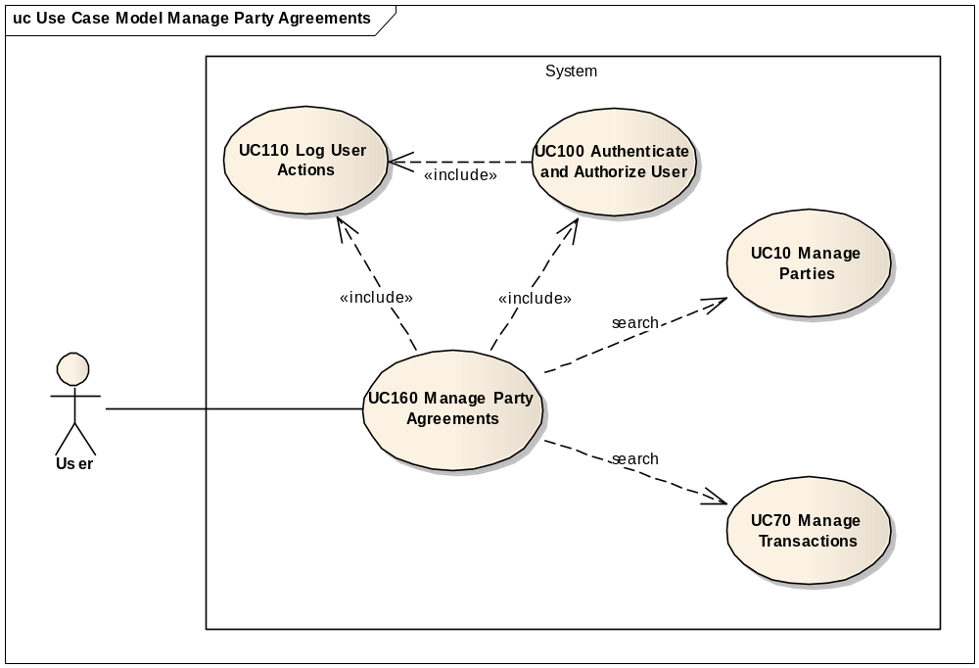

Flow of events
The conventions described in User Interface Generic Conventions document must be applied.

Basic Creation Flow

User chooses the Create Party Agreement menu action
ID | Description
UC160_BR01 | User needs to have the correct access rights in order to access this feature. Please see UC 0100 - eTrustEx Admin Console - Authenticate and Authorise User, section 6.3 User Access Rights for more information.
User selects Business Configuration > Party Agreement > Create option from e-TrustEx Administration Console home page (as shown in section 7.1 Accessing Party Agreement Operations).

System displays the "Create Party Agreement" page
The System displays the Create Party Agreement page as described in paragraph 7.2 "Create Party Agreement" page.
ID | Description
UC160_BR02 | Authorization on all transactions is defaulted to Yes.

User enters information and chooses the Save option
- The user selects the authorizing and delegated parties of the party agreement by using the search option to find the desired party (see subflow S1: Search for an Authorizing / Delegated Party)
- The user specifies if the authorization is given on all transactions
- User chooses save option.

System creates the Party Agreement
ID | Description
UC160_BR03 | Authorizing party is mandatory.
UC160_BR04 | Delegated party is mandatory.
UC160_BR05 | Authorizing and Delegated parties must pertain to the business domain selected in the application header.
UC160_BR06 | If Authorized on all transactions is set to No, at least one transaction needs to be specified.
UC160_BR14 | Authorizing party must not be a third party.
UC160_BR15 | Delegated party must be a third party.
UC160_BR16 | No other party agreement must already exist between the authorizing party and the delegated party.
- System validates the page according to the business rules.
- System saves the Party Agreement, and the party agreement - transaction associations where needed.
- System logs the successful creation: include use case Log CIPAdmin User Actions
- System informs the user about the success of the operation

User acknowledges the successful message

System redisplays the saved Party Agreement in view mode
- System goes to step 2.3.2 in 2.3 Basic Visualization Flow.

The basic creation flow ends.

Basic search flow
ID | Description
UC160_BR01 | User needs to have the correct access rights in order to access this feature. Please see UC 0100 - eTrustEx Admin Console - Authenticate and Authorise User, section 6.3 User Access Rights for more information.

User selects the Search Party Agreement menu action
User selects Business Configuration > Party Agreement > Search option from e-TrustEx Administration Console home page (as shown in section 7.1 Accessing Party Agreement Operations).

System displays the "Search Party Agreement" page
System displays the search page as described in paragraph 7.3 "Search Party Agreement" page.

User enters the search criteria
- User enters one or more search criteria. A search criterion left empty means the concerned field will not be taken into account. The user can search by:
    - Authorizing party
    - Delegated party
    - An authorized transaction
- User activates the search button.

The System searches the Party Agreements
ID | Description
UC160_BR07 | A field left empty or containing only spaces is not taken into account during the search.
UC160_BR08 | Character case is ignored.
UC160_BR09 | At least one search field should be filled in.
The system searches the party agreement items that satisfy all the entered criteria.
The results are filter on the business domain selected in the application header (which means that only the party agreements between parties in this business domain will be displayed).
If a transaction is specified in the search criteria, all party agreements authorising at least this transaction will be displayed, provided the rest of the above mentioned criteria is satisfied. Note that party agreements authorising all transactions have no transactions linked to them, these party agreements shall also be displayed in the results.

System displays the Party Agreements found
The system displays the list of Party Agreements corresponding to the search criteria, showing the following information:
  - Name of authorizing party
  - Name of delegated party
  - If party agreement is authorized for all transactions or not

User views the result list
- User can view the details of a Party Agreement by clicking on its corresponding line in the list (see 2.3. Basic Visualization Flow)
- User can launch a new search

The basic search flow ends.

Basic Visualization Flow
ID | Description
UC160_BR01 | User needs to have the correct access rights in order to access this feature. Please see UC 0100 - eTrustEx Admin Console - Authenticate and Authorise User, section 6.3 User Access Rights for more information.

User has successfully saved a party agreement using the creation/modification flow or at step 2.2.6, User clicks a Party Agreement in the list

System opens the Party Agreement visualization page
Please see section 7.4 "View Party Agreement" page.
- System reads the data
- System loads data on screen
- All fields are protected
- "Cancel", "Edit" and "Delete" buttons are made available

User visualises the details of the Party Agreement:
- User can return to the result list by choosing "Cancel", the view flow ends and basic search flow restarts at 2.2.6
- User can edit a Party Agreement (see 2.4 Basic Modification Flow)
- User can delete a Party Agreement (see 2.5. Basic Deletion Flow)

Visualization flow ends.

Basic Modification Flow
ID | Description
UC160_BR01 | User needs to have the correct access rights in order to access this feature. Please see UC 0100 - eTrustEx Admin Console - Authenticate and Authorise User, section 6.3 User Access Rights for more information.

At 2.3.3., The User chooses to edit a Party Agreement

System opens the Party Agreement page in edit mode
Please see section 7.5 "Modify Party Agreement" page.
- Authorizing party is read-only;
- "Cancel", "Reset" and "Save" options are present.

User makes the changes
User operates the desired changes and chooses the save option.

The system saves the modified Party Agreement
ID | Description
UC160_BR17 | Authorizing party cannot be changed.
UC160_BR04 | Delegated party is mandatory.
UC160_BR05 | Authorizing and Delegated parties must pertain to the business domain selected in the application header.
UC160_BR06 | If Authorized on all transactions is set to No, at least one transaction needs to be specified.
UC160_BR10 | Delegated party cannot be changed if there are messages in the system having the authorized party as sender and the delegated party as issuer.
UC160_BR11 | Authorized transactions cannot be deleted if there are messages in the system having the authorized party as sender and the delegated party as issuer.
UC160_BR15 | Delegated party must be a third party.

- The system validates the page according to the business rules.
- The system saves the Party Agreement and creates or removes the party agreement - transaction associations corresponding to the added or removed transactions in the list of authorized transactions.
- System logs the successful modification: include use case Log CIPAdmin User Actions
- The System informs the user about the success of the operation

User acknowledges the successful message

System redisplays the Party Agreement in view mode
- System goes to step 2.3.2 in 2.3 Basic Visualization Flow.

The Modification flow ends.

Basic Deletion Flow
ID | Description
UC160_BR01 | User needs to have the correct access rights in order to access this feature. Please see UC 0100 - eTrustEx Admin Console - Authenticate and Authorise User, section 6.3 User Access Rights for more information.

At 2.3.3., User chooses to delete the Party Agreement
ID | Description
UC160_BR12 | There shall be no messages in the system having the authorizing party as sender and the delegated party as issuer.
UC160_BR13 | If this is the only party agreement for the authorizing party and the authorizing party has not credentials, there shall be no interchange agreement configured for the authorizing party (such interchange agreement will become useless as the sender has no means to connect and send messages).

System asks for deletion confirmation

User confirms the deletion
If user chooses to cancel the deletion, he is returned to the visualization page (2.3.3.).

System deletes the Party Agreement
- System verifies the business rules
- System deletes the Party Agreement and party agreement - transaction associations if any
- System logs the successful deletion: include use case Log CIPAdmin User Actions

System notifies user of the success of the operation

User acknowledges the message

The Deletion Flow ends.

Subflows

S1: Search for an Authorizing / Delegated Party and select it
- User chooses Search option next to the concerned party field
- System opens a Party Search Popup: include section 2.2. Basic Search Flow (from step 2.2.2. System displays the "Search Party" page) of Manage Parties Use Case. Note: The business domain selected in the application header is automatically selected in the Party Search Popup and cannot be changed. When searching for an authorizing party, the third party flag is set to No in the Party Search Popup and cannot be changed. Similar, when searching for a delegated party, the third party flag is set to Yes in the Party Search Popup and cannot be changed.
- System fills in the corresponding read-only field with the party name of the party returned at previous step

Alternative Flows

AC1: at step 2.1.3., User chooses Cancel option
- System disregards all information provided by User
- System closes the page
- System redirects the user to CIPAdmin home page
- Use Case ends

AC2: at step 2.1.3, User chooses page Clear option
- Systems disregards all information provided by the user
- Alternate flow ends and basic creation flow restarts at 2.1.2.

AC3: at step 2.1.3, user does not want authorization on all transactions
- User changes authorization on all transactions selection to No
- System displays the authorized transactions section
- User chooses Add transaction option at the top of the section
- System opens a Transaction Search Popup: include section 2.2. Basic Search Flow of Manage Transaction Use Case.
- System adds the transaction returned at the previous step to the authorized transactions list
- User can authorize a number of transactions: steps (3) to (5) will be repeated in this case for each new transaction
- Alternate flow ends and basic flow continues at 2.1.3

AS1: at step 2.2.4, no party agreement found for the specified criteria
- The system notifies the user that no party agreements have been found
- Alternate flow ends and basic search flow restarts at 2.2.3

AM1: at step 2.4.3, User chooses Cancel option
- System disregards all information provided by User
- System closes the page
- Alternate flow ends and basic flow restarts at 2.3.2 (visualization page).

AM2: at step 2.4.3, User chooses Reset option
- Systems disregards all information provided by the user
- Alternate flow ends and basic modification flow restarts at 2.4.2.

A1: at steps 2.1.3, or 2.4.3, User chooses to search for a Transaction
- System opens a Transaction Search Popup: include section 2.3. Basic Search Flow (from step 2.2.2. System displays the Search Transaction page) of Manage Transaction Use Case.
- System adds a new row to the Authorized transactions table and fills in the information of the transaction returned at previous step: transaction name in the Name column and the transaction version in the Version column
- Alternate flow ends and basic flow continues at 2.1.3, respectively 2.4.3.

A2: at steps 2.1.3 or 2.4.3, User chooses to clear the corresponding Authorizing Party or Delegated Party
- User chooses the clear button next to the field he / she wants to clear
- System removes the selected value from the read only field
- Alternate flow ends and basic flow continues at 2.1.3, respectively 2.4.3.

A3: at step 2.1.3 or 2.4.3, the user wants to remove a transaction from the authorized transactions list
ID | Description
UC160_BR11 | Authorized transactions cannot be deleted if there are messages in the system having the authorized party as sender and the delegated party as issuer.

- User chooses the remove action corresponding to the authorized transaction to remove
- System checks the business rule
- Depending of the outcome of the check, System removes the transaction from the list of authorized transactions or informs the user the transaction will not be removed by providing the reason
- Repeat steps (1) to (3) for each transaction to remove
- Alternate flow ends and basic flow continues at 2.1.3 or 2.4.3 respectively

Exceptional Flows

E1: at steps 2.1.1, 2.2.1, 2.4.1 or 2.5.1 user is not authorized for the operation
Include the steps in section 2.4.1 of Authenticate and Authorise User Use Case.

E2: at step 2.1.4 or 2.4.4, Business Rules are not verified
- System logs the error: include use case Log CIPAdmin User Actions
- The system highlights the field(s) in error
- The System displays the error messages.
- Flow restarts at 2.1.3, respectively 2.4.3.

E3: at step 2.1.4 or 2.4.4, there is an error when saving the party agreement
- System logs the error: include use case Log CIPAdmin User Actions
- The system informs the user about the error.
- Use case ends.

E4: at step 2.5.4, there is an error when deleting the party agreement
- System logs the error: include use case Log CIPAdmin User Actions
- The system informs the user about the error.
- Use case ends.

E5: at any step, a technical error occurs
- System logs the error: include use case Log CIPAdmin User Actions
- The system informs the user about the error.
- Use case ends.

Special Requirements

Interface(s) with other Systems

Security Requirements

Other Special Requirement

Preconditions
- User must be registered user of CIPAdmin tool
- User must be logged in & successfully authenticated on the e-TrustEx Admin Console

Post conditions
- [Success] The Party Agreement has been successfully created / modified / deleted.
- [Failure] The System logs the failure reason and the context, the use case is aborted and the primary actor has been notified of the reasons.

Additional Information

Includes
- For operation authorization: UC 0100 - eTrustEx Admin Console - Authenticate and Authorise User
- For logging: UC 0110 - eTrustEx Admin Console - Log CIPAdmin User Actions
- For searching or visualizing a party: UC 0010 - eTrustEx Admin Console - Manage Parties
- For searching a transaction: UC 0070 - eTrustEx Admin Console - Manage Transaction

Extends
N/A

Mock-up screens

Accessing Party Agreement Operations
Figure 1 - Accessing Party Agreement Operations
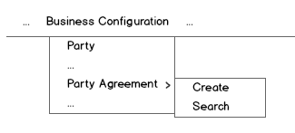

"Create Party Agreement" page
Figure 2 – New Party Agreement: Delegate all transactions
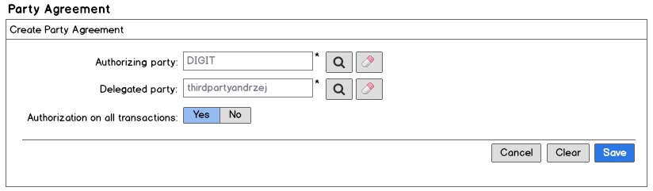
- The authorizing and delegated party fields are read only. They are automatically filled in by the system when user selects a party in the corresponding search page that can be accessed via the search button next to the concerned field.
- The clear button next to each read only field, gives the option to clear the content of the corresponding field
- Search and clear buttons have associated hints that describe what they serve for
  - Search button – Open search for authorizing/delegated party
  - Clear option – Remove selected party
- The authorization on all transaction is defaulted to Yes
- When the authorization on all transactions is set to No, the System shows the section Authorized transactions (like in Figure 3 - New Party Agreement: Delegate specific transactions):
  - The user can add a transaction to the authorized transaction list, by selecting a transaction in the transaction search page that can be accessed via the add button found in the section header (button shall display hint add transaction to authorize)
  - Transactions in the authorized transactions list can be removed by using the remove button corresponding to the transaction to be removed (button shall display hint remove transaction from authorized list)
- Starred fields are mandatory.
- Clear, Cancel and Save options are present.
Figure 3 - New Party Agreement: Delegate specific transactions
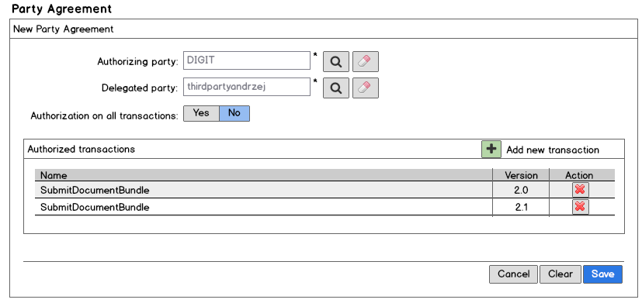

"Search Party Agreement" page
Figure 4 - Search Party Agreement
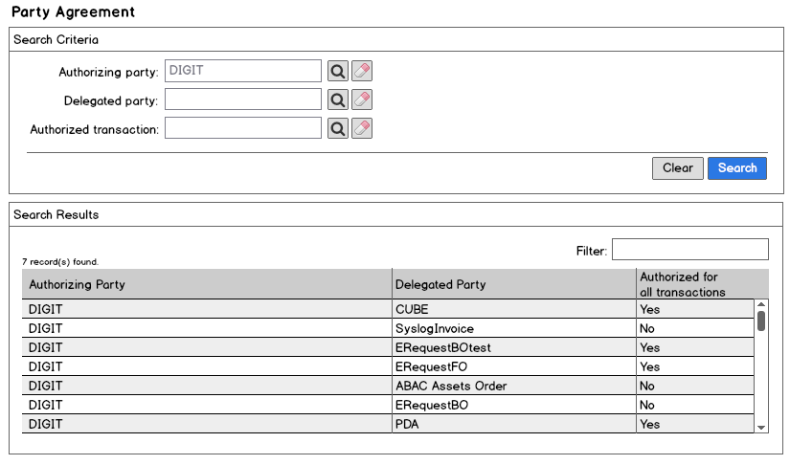
- Search Criteria section
  - See points (1) to (3) from section 7.2 "Create Party Agreement" page.
  - Clear and Search options are present.
- Search Results section
  - The number of results found is shown to the user
  - A filter on the results is also made available to the user: filtering applies on all columns in a row
  - The results list shows the following information
    - The authorizing party name
    - The delegated party name
    - Yes, if the party agreement is authorizing the delegated party for all transactions; No, otherwise
  - The results list is ordered by authorizing party name in ascendant alphabetical order and ignoring case.
  - The lines in the results list are interactive, and clicking on one of them will show the details of the party agreement corresponding to it

"View Party Agreement" page
Figure 5 - View Party Agreement: Delegation on all transactions
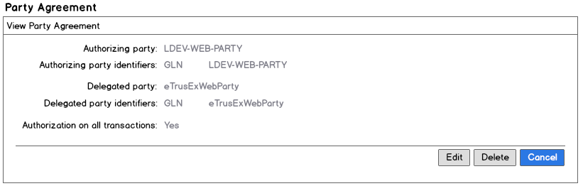
Figure 6 - View Party Agreement: Delegation on specific transactions
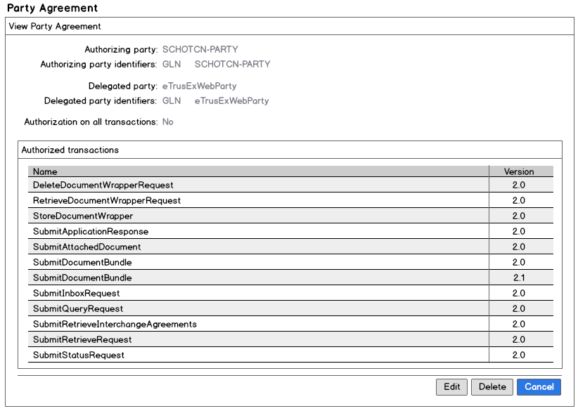
- The System shows
  - The name and identifiers (pairs of type and value) of the authorizing party
  - The name and identifiers (pairs of type and value) of the delegated party
  - The name and version of the authorized transactions, if not all transactions are authorized
- Edit, Delete and Cancel options are present.

"Modify Party Agreement" page
Figure 7 - Modify Party Agreement: Delegation on all transactions
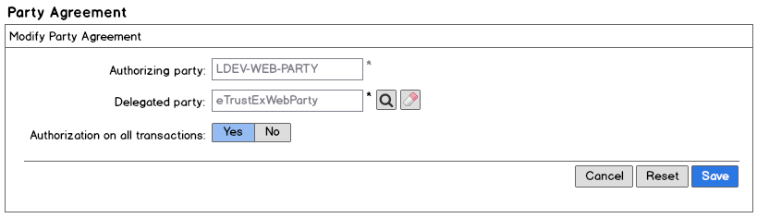
- Points (1) to (3) from section 7.2 "Create Party Agreement" page apply except for the authorizing party which is protected.
- Point (5) from section 7.2 "Create Party Agreement" page applies also for the modification
- When the authorization on all transactions is set to Yes, the section Authorized transactions is not displayed anymore
- Starred fields are mandatory.
- Reset, Cancel and Save options are present.

"Delete Party Agreement" page
Figure 8 - Delete Party Agreement Confirmation
